SELECT within SELECT Tutorial

1. SELECT name FROM world WHERE population > (SELECT population FROM world WHERE name='Russia')

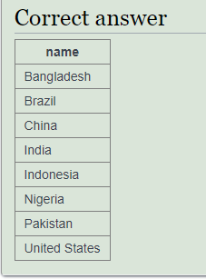

1. select name from world where continent = 'Europe' and gdp/population > (select gdp/population from world where name = 'United Kingdom')

|  |
| --- |
| **name** |
| Andorra |
| Austria |
| Belgium |
| Denmark |
| Finland |
| France |
| Germany |
| Iceland |
| Ireland |
| Liechtenstein |
| Luxembourg |
| Monaco |
| Netherlands |
| Norway |
| San Marino |
| Sweden |
| Switzerland |

1. select name, continent from world where continent in ('South America','Oceania') order by name

|  |  |
| --- | --- |
| **name** | **continent** |
| Argentina | South America |
| Australia | Oceania |
| Bolivia | South America |
| Brazil | South America |
| Chile | South America |
| Colombia | South America |
| Ecuador | South America |
| Fiji | Oceania |
| Guyana | South America |
| Kiribati | Oceania |
| Marshall Islands | Oceania |
| Micronesia, Federated States of | Oceania |
| Nauru | Oceania |
| New Zealand | Oceania |
| Palau | Oceania |
| Papua New Guinea | Oceania |
| Paraguay | South America |
| Peru | South America |
| Saint Vincent and the Grenadines | South America |
| Samoa | Oceania |
| Solomon Islands | Oceania |
| Suriname | South America |
| Tonga | Oceania |
| Tuvalu | Oceania |
| Uruguay | South America |
| Vanuatu | Oceania |
| Venezuela | South America |

1. select name, population from world where population > (select population from world where name = 'Canada') and population < (select population from world where name = 'Poland')

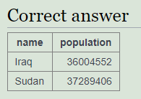

1. select name, concat(round(100*population/(select population from world where name = 'Germany')),'%') from world where continent = 'Europe'

|  |  |
| --- | --- |
| **name** | **concat(round(..** |
| Albania | 3% |
| Andorra | 0% |
| Austria | 11% |
| Belarus | 12% |
| Belgium | 14% |
| Bosnia and Herzegovina | 5% |
| Bulgaria | 9% |
| Croatia | 5% |
| Czech Republic | 13% |
| Denmark | 7% |
| Estonia | 2% |
| Finland | 7% |
| France | 82% |
| Germany | 100% |
| Greece | 14% |
| Hungary | 12% |
| Iceland | 0% |
| Ireland | 6% |
| Italy | 75% |
| Kazakhstan | 21% |
| Latvia | 2% |
| Liechtenstein | 0% |
| Lithuania | 4% |
| Luxembourg | 1% |
| Macedonia | 3% |
| Malta | 1% |
| Moldova | 4% |
| Monaco | 0% |
| Montenegro | 1% |
| Netherlands | 21% |
| Norway | 6% |
| Poland | 48% |
| Portugal | 13% |
| Romania | 25% |
| San Marino | 0% |
| Serbia | 9% |
| Slovakia | 7% |
| Slovenia | 3% |
| Spain | 58% |
| Sweden | 12% |
| Switzerland | 10% |
| Ukraine | 53% |
| United Kingdom | 79% |
| Vatican City | 0% |

1. select name from world where gdp > (select max(gdp) from world where continent in ('Europe') and gdp is not null)

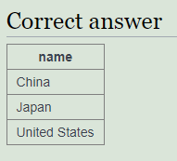

1. SELECT continent, name, area FROM world x WHERE area >= ALL (SELECT max(area) FROM world y WHERE continent=x.continent AND area>0)

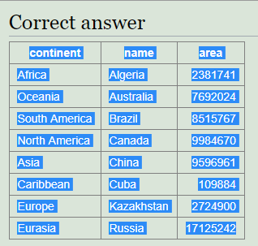

1. SELECT continent, name FROM world x WHERE name <= ALL(SELECT name FROM world y WHERE y.continent=x.continent)

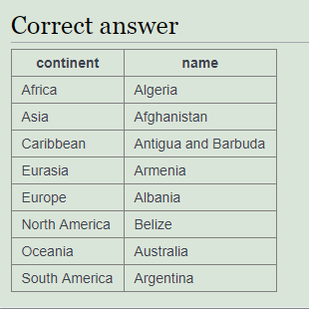

1. select name, continent, population from world x WHERE 25000000 >= ALL(SELECT population FROM world y WHERE x.continent = y.continent AND y.population>0);

|  |  |  |
| --- | --- | --- |
| **name** | **continent** | **population** |
| Antigua and Barbuda | Caribbean | 86295 |
| Australia | Oceania | 23545500 |
| Bahamas | Caribbean | 351461 |
| Barbados | Caribbean | 285000 |
| Cuba | Caribbean | 11167325 |
| Dominica | Caribbean | 71293 |
| Dominican Republic | Caribbean | 9445281 |
| Fiji | Oceania | 858038 |
| Grenada | Caribbean | 103328 |
| Haiti | Caribbean | 10413211 |
| Jamaica | Caribbean | 2717991 |
| Kiribati | Oceania | 106461 |
| Marshall Islands | Oceania | 56086 |
| Micronesia, Federated States of | Oceania | 101351 |
| Nauru | Oceania | 9945 |
| New Zealand | Oceania | 4538520 |
| Palau | Oceania | 20901 |
| Papua New Guinea | Oceania | 7398500 |
| Saint Lucia | Caribbean | 180000 |
| Samoa | Oceania | 187820 |
| Solomon Islands | Oceania | 581344 |
| Tonga | Oceania | 103036 |
| Trinidad and Tobago | Caribbean | 1328019 |
| Tuvalu | Oceania | 11323 |
| Vanuatu | Oceania | 264652 |

1. SELECT name, continent FROM world x WHERE population >= ALL(SELECT population*3 FROM world y WHERE x.continent = y.continent and y.name != x.name)

